THIS FORM IS AN AGREEMENT FOR A FACE TO FACE APPOINTMENT

Personal Details

Name:

Address:

About Me:

I confirm that I have not had any of the following symptoms in the last 14 days: fever, shortness of breath, loss of sense of taste or smell, dry cough, sore throat.

Yes No

I confirm that I am not in the clinically extremely vulnerable category and therefore advised to shield at home by the government.

Yes No

I confirm that to the best of my knowledge, I have not been in close contact with anyone with confirmed COVID-19 in the last 14 days.

Yes No

I understand that coronavirus may not cause symptoms in some people and is currently causing a pandemic which means healthcare services are required to operate differently

Yes No

About my Visit:

I confirm I am aware of the clinic’s requirement for social distancing in the clinic.

Yes No

I confirm I am aware of the clinic’s requirement for hand decontamination in the clinic:

Yes No

I confirm I am aware the clinic requires me to wear a face-covering whilst inside the clinic:

Yes No

I confirm I have been told/read about the cleaning of the clinic room before/after my attendance.

Yes No

I understand that my physiotherapist is required to wear PPE as set by Public Health authorities during my appointment and this is not optional for them.

Yes No

About my Clinician:

They have confirmed they have not had any of the following symptoms in the last 14 days: fever, shortness of breath, loss of sense of taste or smell, dry cough, runny nose or sore throat:

Yes No

They have confirmed that to the best of their knowledge, they have not been in close contact with anyone with confirmed COVID-19 in the last 14 days.

Yes No

I understand that I will have the opportunity to ask all the questions I wish to, and all of my questions will have been answered to my satisfaction before any consultation/ treatment. Use space below to record specific details, if you wish to.

I agree to attend a face to face appointment during the COVID-19 pandemic.

Yes No Signed by Patient ………………………………………………………………………..

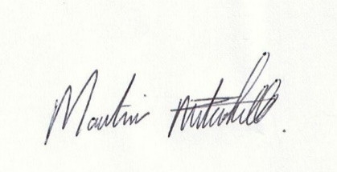
OR [delete as applicable Signature of person with parental responsibility / person legally entitled to sign on behalf of a person who lacks capacity.

--------------------------------------------------------------------------

Signature of Physiotherapist Date: /0 7 / 2020

Exemptions to wearing face masks may apply. P.T.O.

